

**University of Windsor**

# Electrical and Computer Engineering Winter 2022

**ELEC-4350: Microelectromechanical Systems (MEMS)**

**Lab Assignment 2**

**Complex Wafer Level Masks using Cell Heirarchy**

**Arsh Dhillon**

**104932740**

**Objective**: To introduce how to generate mask array from a single cell to use it on the wafer and alignment of the mask array with the wafer using Blueprint, IntelliFab and FabSim.

# Step 1. Preparation

1. We opened the perfect_comb.vec located in C:\Intellisuite\Training\TEM\Comb drive\, Created an array of the mask and saved it as perfect_comb_array_sutdent-ID.vec in the working folder

# Step 3. Create the Blueprint

The vec file perfect.comb.vec was opened. The geometry can be modified from here.

1. We created a new block and clicked “Add from File” -> Select “perfect_comb.vec” as the reference.

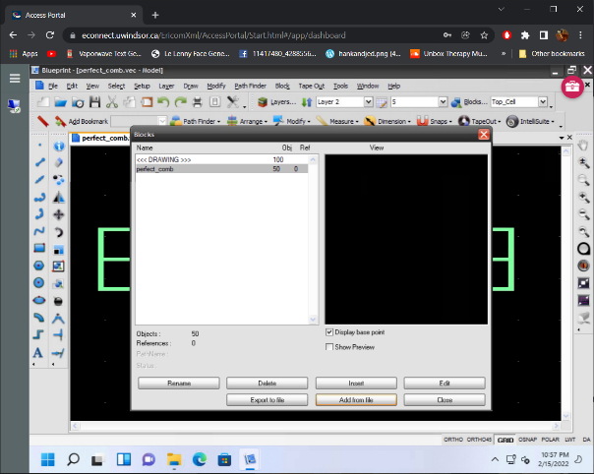

104932740

Figure 1: Creating a comb block.

1. Now we create an array of the comb drive block using *Insert Block*. In my instance I chose the settings below.

Figure 2: Creating an Array.

1. Now we reset the origin to the middle point of the array. We used *Reset Base Point/Origin.* The origin was found by manual inspection.

Figure 3: Resetting Origin.

1. We have successfully created our array and redefined the origin. The result is shown below.

Figure 4: Final Array with Correct Origin

# Step 4. Modifying the Blueprint

# We start by saving the file as *perfect_comb_array_104932740.* Now we start with our first modification. Select *LAYER 1* in the top settings*.* We used the *Create Rectangle* tool to draw two equal rectangles at the left bottom corner of the die. These rectangles are then both selected. Now we click on *Path Finder -> Union* to join these figures and create a “+”.

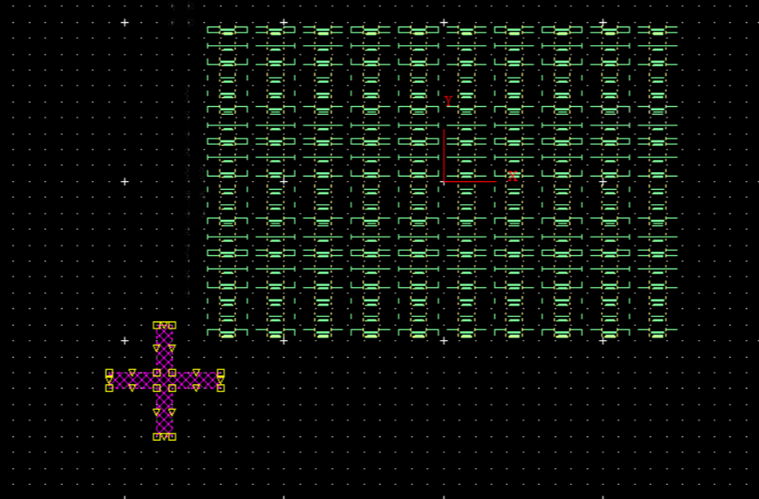

Figure 5: First Plus

1. Now we repeat this process in the upper right corner. We select the previous plus and use the *Mirror* feature to copy it exactly in the new spot (STILL **LAYER 1)**.

Figure 6: Second Plus

1. Now we select ***LAYER 2.*** We draw two congruent but bigger rectangles over the outline of the previous ones. The scale is kept consistently big. We use *Union* again to combine these new rectangles into a “+”. The overlap is our guide point.

Figure 7: First Plus in LAYER 2

1. Now we use the *Mirror* Function once more to repeat the plus over on the top right. Make sure it uniformly overlaps the previous ***LAYER 1*** plus.

Figure 8: Second Plus in LAYER 2

1. Now for our last modification, we download the UWin logo from google. Then we click on *file-> Import -> IMG file -> .png.* We select the downloaded logo and import it into the blueprint.

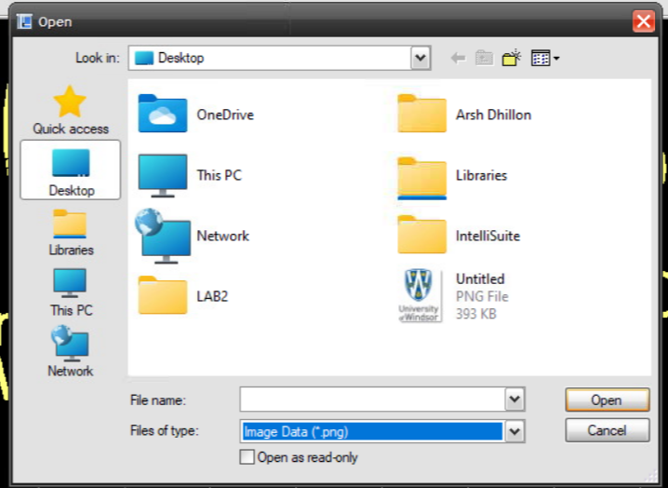

Figure 9: Importing Logo

1. Now we select the whole logo, and click *Join* to simplify it. We use the *Draw -> Add Multiline Text,* to add our information as below. Lastly we select all of the newly added test and click on the above *Tool -> Convert Text to Polygon* toolbar to convert the text into Polygon so it can processed in Intellifab.

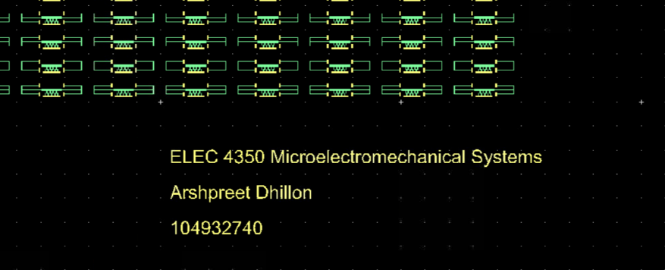

Figure 10: Adding last modifications.

1. Hence our blueprint is finally complete. We save it and proceed to Intellifab.

Figure 11: Blueprint

# Open the Fab file:

IntelliFab was opened and then perfect_comb.fabx was located in our lab folder perfect_comb_array_104932740.vec file was selected as a mask. **The fabrication processes are reviewed.**

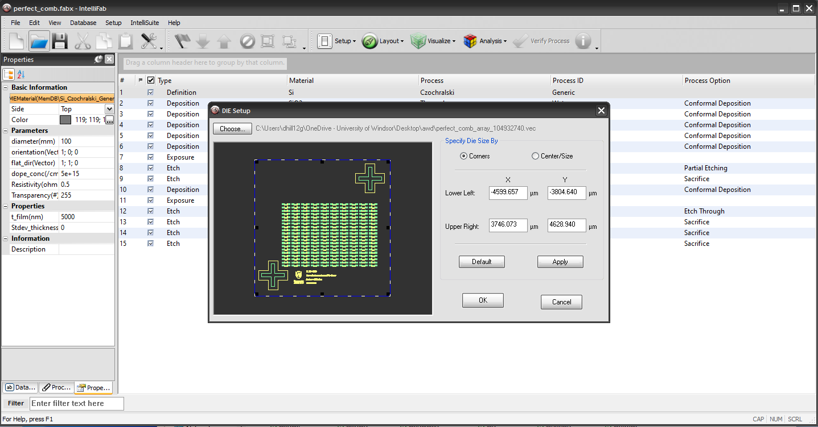

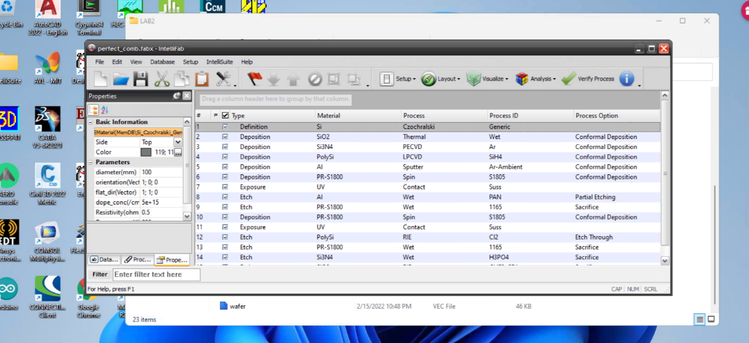

Figure 12: Using Intellifab

# Step 5. Electromechanical Analysis

The fabrication process in IntelliFab is simulated and the geometrical accuracy is ensured.

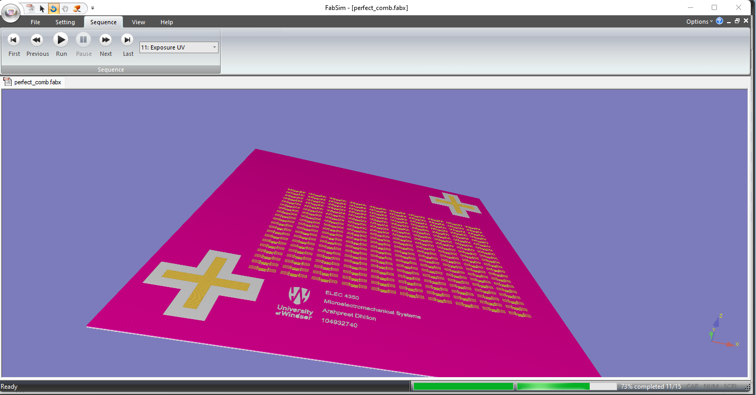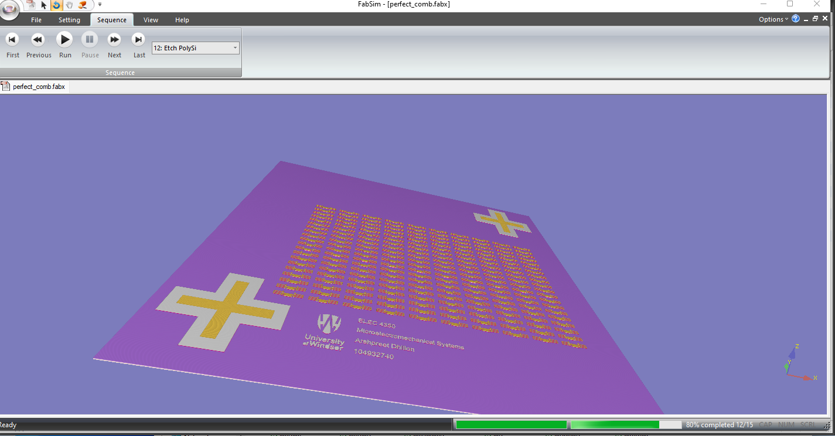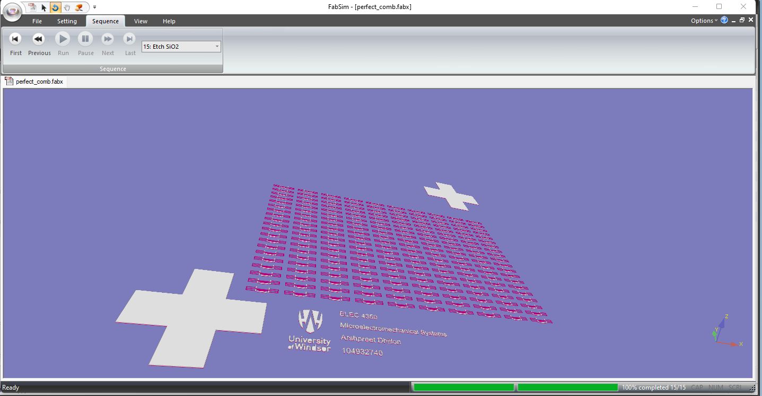Figure 14: Simulation of the Fabrication Process

**Discussion**

As we can see, our fabrication was successful. A video of the process has been attached in the zip file. Overall the “+“ ‘s help us align the layers over each other as to ensure accuracy.